**Vision statement – Application of Benford's law**

**By:  
Koren Levi   
Dor Yaakobi  
 Natali Djavarov**

What is Benford's law?

**Benford's law**, also known as the Newcomb–Benford law, the law of anomalous numbers, or the **first-digit law**, is an observation that in many real-life sets of numerical data, the leading digit is likely to be small.  
In sets that obey the law, the number 1 appears as the leading significant digit about 30% of the time, while 9 appears as the leading significant digit less than 5% of the time (4.6%).

*Definition*

A set of numbers is said to satisfy Benford's law if the leading digit ***d***(*d* ∈ {1, ..., 9}) occurs with [**probability**](https://en.wikipedia.org/wiki/Probability)**.**

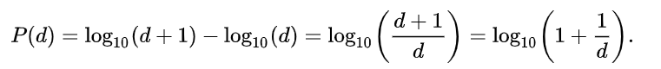

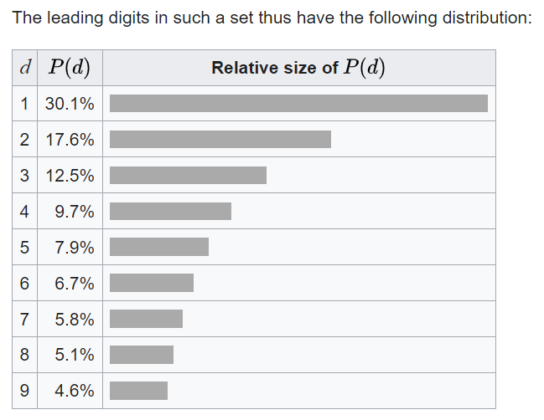�(�)=log10⁡(�+1)−log10⁡(�)=log10⁡(�+1�)=log10⁡(1+1�).

It has been shown that **Benford's law** applies to a **wide variety of data sets,** including electricity bills, street addresses, stock prices, house prices, population numbers, death rates, lengths of rivers, and physical and mathematical constants. It's important to say that not all data sets apply Benford's law.

*What are the Constraints in Using Benford’s Law?*

The assumptions regarding the data to be examined by Benford’s Law are:

* Numeric data
* Randomly generated numbers:
* Not restricted by maximums or minimums
* Not assigned numbers
* Large sets of data (more than 1000)
* Magnitude of orders – at least 3 (numbers migrate up through 10, 100, 1,000, 10,000)

*Examples*

1. A recent example is Mark Nigrini’s research, which showed that Benford’s Law could be used as **an indicator of accounting and expenses fraud**.
2. One fraudster wrote numerous checks to himself just below US $100,000 (a policy and procedure threshold), causing digits 7, 8 and 9 to have aberrant percentages of actual occurrence in a Benford’s Law analysis.
3. Digital analysis using Benford’s Law was also used as evidence of voter **fraud in the 2009 Iranian election**.
4. In fact, Benford’s Law is legally admissible as evidence in the US in criminal cases at the federal, state and local levels. This fact alone substantiates the potential usefulness of using Benford’s Law.
5. Benford’s Law (BL) is used for Tax companies, Banks, and other financial services companies who want to detect financial fraud. All in all, the BL is a tool that helps financial services companies to protect their customers from a fraud. Unlike other security tools, the BL checks the data and allows the customers to remain safe from being schemed.

**Project Requirements Document  
  
Applications of Benford's Law**

The purpose of the project

The purpose of the project is to produce a BL-software that will provide financial companies like Banks with the ability to protect their customers from being a victim of financial fraud.

Goals For the Release Criteria

***Functionality***

The BL-software will alert a red-flag in case there is a large deviation from the distribution that defines the BL, and then determine if there is a high possibility of a fraud.

***Usability***

The user does not need to operate the system, as the system is scanning non-stop the data automatically.

***Reliability***

The BL-software will support manual insertion.

***Performance***

The BL-software will give real-time analysis.

***Supportability***

The BL-software will support many common devices.

Determine the Timeline

End of 2022-2023 academic year.